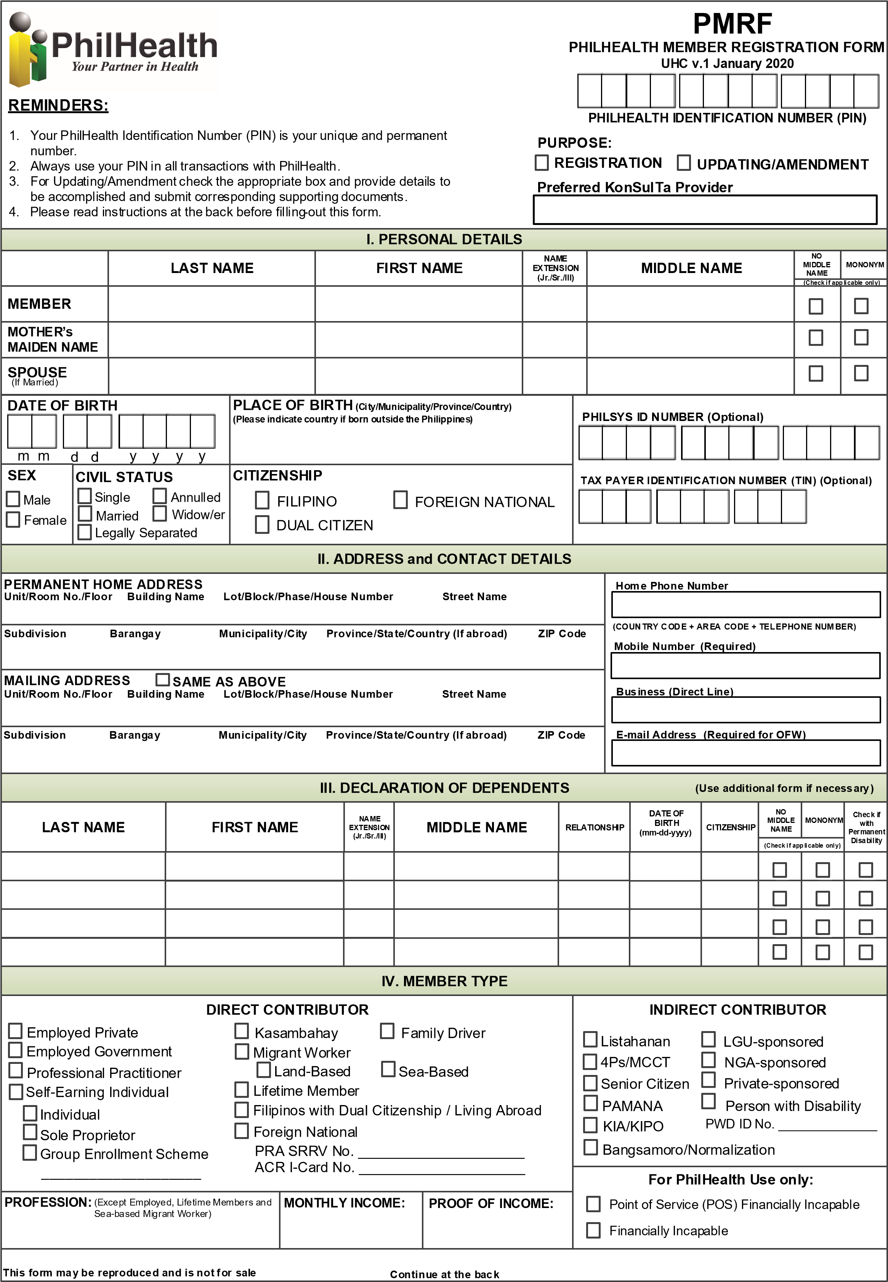

N/A

N/A

N/A

N/A

N/A

N/A

N/A

N/A

FILIPINO

12/21/68

FATHER

CAMAHALAN

JESUS

PAHUNANG

**09354517426**

**088 + 8805616**

**Lapasan Cagayan de Oro City Misamis Oriental Philippines 9000**

**128 San Juan 1**

**Cagayan de Oro City Misamis Oriental Philippines**

2 0 0 1

1 8

0 1

OLIMBA

ROSE MARIE

TERCO

TERCO

JOHN PATRICK

PAHUNANG

|  |  |  |  |
| --- | --- | --- | --- |
| **V. UPDATING/AMENDMENT** | | | |
| **Please check:** | **FROM** | **TO** | |
| Change/Correction of Name  (Last Name, First Name, Name Extension (Jr./Sr./III) Middle Name) |  |  | |
| Correction of Date of Birth |  |  | |
| Correction of Sex |  |  | |
| Change of Civil Status |  |  | |
| Updating of Personal Information/Address/  Telephone Number/Mobile Number/e-mail Address |  |  | |
| Under penalty of law, I hereby attest that the information provided, including the documents I have attached to this form, are true and accurate to the best of my knowledge. I agree and authorize PhilHealth for the subsequent validation, verification and for other data sharing purposes only under the following circumstances:   * As necessary for the proper execution of processes related to the legitimate and declared purpose; * The use or disclosure is reasonably necessary, required or authorized by or under the law; and, * Adequate security measures are employed to protect my information.   JOHN PATRICK T. PAHUNANG MARCH 7 2022  _________________________________________________ _________________  **Member’s Signature over Printed Name Date** Please affix right  thumbmark if unable to write | | | **FOR PHILHEALTH USE ONLY** |
| Full Name  :  JOHN PATRICK T. PAHUNANG  PRO  /  LHIO  /  Branch  :    CAGAYAN DE ORO____  Date  &  Time  :    _____MARCH 7 , 2022_________________  **RECEIVED BY**  **:** |
| **INSTRUCTIONS**   1. All information should be written in UPPER CASE/CAPITAL LETTERS. If the information is not applicable, write “N/A.” 2. All fields are mandatory unless indicated as optional. By affixing your signature, you certify the truthfulness and accuracy of all information provided. 3. A properly accomplished PMRF shall be accompanied by a valid proof of identity for first time registrants, and supporting documents to establish relationship between member and dependent/s for updating or request for amendment. 4. On the PURPOSE, check the appropriate box if for **Registration** or for **Updating/Amendment** of information. 5. Indicate preferred KonSulTa provider near the place of work or residence. 6. For PERSONAL DETAILS, all name entries should follow the format given below. Check the appropriate box if registrant has no middle name and/or with single name (mononym).   **LAST NAME FIRST NAME NAME EXTENSION (Jr./Sr./III) MIDDLE NAME** SANTOS JUAN ANDRES III DELA CRUZ   1. Indicate registrant’s/member’s name as it appears in the birth certificate. 2. The full mother’s maiden name of registrant/member must be indicated as it appears in the birth certificate. 3. Indicate the full name of spouse if registrant/member is married. 4. Indicate the complete permanent and mailing addresses and contact numbers. 5. For updating/amendment, check the appropriate box to be updated/amended and indicate the correct data. 6. For MEMBER TYPE, check the appropriate box which best describes your current membership status. 7. For Direct Contributors, except employed, sea-based migrant workers and lifetime members, indicate the profession, monthly income and proof of income to be submitted. 8. For Self-earning individuals, Kasambahays and Family Drivers, indicate the actual monthly income in the space provided. 9. In declaring dependents, provide the full name of the living spouse, children below 21 years old, and parents who are 60 years old and above totally dependent to the member. 10. Dependents with disability shall be registered as principal members in accordance with Republic Act 11228 on mandatory PhilHealth coverage for all persons with disability (PWD). 11. The registrant must affix his/her signature over printed name (or right thumbmark if unable to write) and indicate the date when the PMRF was signed. | | | |